Investigator name – Alfuzosin data – 09/28/2006 – Grunwald

Methods:
I’ve carried out three types of analyses to answer your question about Alfuzosin.
1. A standard significance test (t-test) to answer the question of whether on average the number of urinations per night differs by more than chance during the periods when you were on and off Alfuzosin.
2. A descriptive analysis.
3. A graphical analysis.

Results:
1. The mean numbers of urinations per night were (mean ± standard error)
Off Alfuzosin: 4.19 ± 0.23 (you were up on average 4.2 times per night)
On Alfuzosin: 2.50 ± 0.19 (you were up on average 2.5 times per night)
A t-test shows that these means differ significantly (by more than natural variation would explain), p < 0.0001. So, you did have about 1.7 fewer urinations per night on average during the period you were on Alfuzosin. This is a large enough number to make a substantial difference in sleep quality, I would think.

2. During the 54 days on Alfuzosin, there were 13 nights with 0 or 1 urinations. There were no such nights during the 38 days off Alfuzosin.
During the 38 days off Alfuzosin, there were 9 nights with 6 or more urinations. There were no such nights during the 54 days on Alfuzosin.

3. Since the observations were made over time, I graphed the nightly number of urinations. The vertical line indicates the end of the Alfuzosin period. The horizontal lines show 2-week means (except the final period which is shorter than 2 weeks).

The graph on the next page shows the same patterns described in 1 and 2 above. There appears to be an increase in urinations during the last two weeks of the Alfuzosin period. For example, during the last 3 weeks on Alfuzosin there were no nights with 0 or 1 voiding. This could be due to a decrease in effectiveness of the medication over time, or possibly you missed a few doses, or there could be something else that changed. Since this was noticed from the graph, I didn’t do a formal statistical test on it.

Based on these analyses, I would say that there were fewer urinations during the period when you were on Alfuzosin, particularly during the first several weeks. The magnitude of the effect as noted above may help you decide if the beneficial effects justify the side-effects. Please keep in mind that many other things might have possibly changed during the period you collected these data, and changes are not necessarily due to the drug.
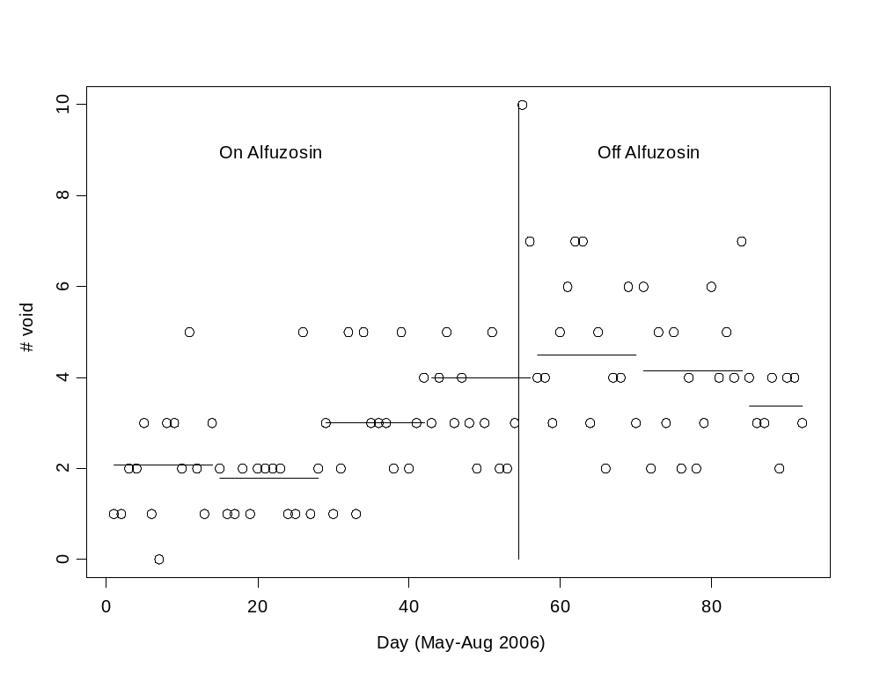

Dear Dr. Grunwald:

Your analysis will help me. The alfuzosin seems helpful in reducing nighttime urination frequency but has some side effects. If your analysis indicates that the alfuzosin is highly efficacious I’ll use it despite the side effects.

Consecutive nightly number of urinations May, June, and July while on alfuzosin follow:

1,1,2,2,3,1,0,3,3,2,5,2,1,3,2,1,1,2,1,2,2,2,2,1,1,5,1,2,3,1,2,5,1,5,3,3,3,2,5,2,3,4,3,4,5,3,4,3,2,3,5,2,2, and 3.

Consecutive nightly number of urinations while off Alfuzosin during, July, and August, immediately following the nights on alfuzosin, follow:

10, 7, 4, 4, 3, 5, 6, 7, 7, 3, 5, 2, 4, 4, 6, 3, 6, 2, 5, 3, 5, 2, 4, 2, 3, 6, 4, 5, 4, 7, 4, 3, 3, 4, 2, 4, 4, and 3.

Respectfully, Gratefully, Yours,

